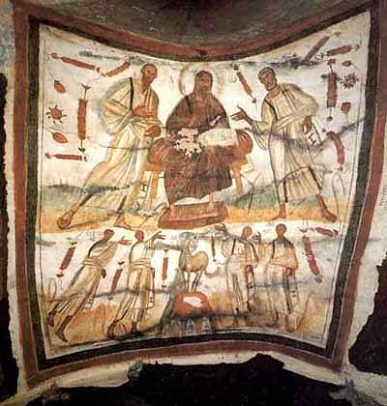

Historical background of the New Testament

**This Sway was started using auto-generated content that the author searched for.**

Most scholars who study the historical Jesus and early Christianity believe that the canonical gospels and life of Jesus must be viewed within his historical and cultural context, rather than purely in terms of Christian orthodoxy. They look at Second Temple Judaism, the tensions, trends, and changes in the region under the influence of Hellenism and the Roman occupation, and the Jewish factions of the time, seeing Jesus as a Jew in this environment; and the written New Testament as arising from a period of oral gospel traditions after his death. [[2](https://en.wikipedia.org/wiki/Historical_background_of_the_New_Testament)]

# Factions, groups and cults in the Roman period

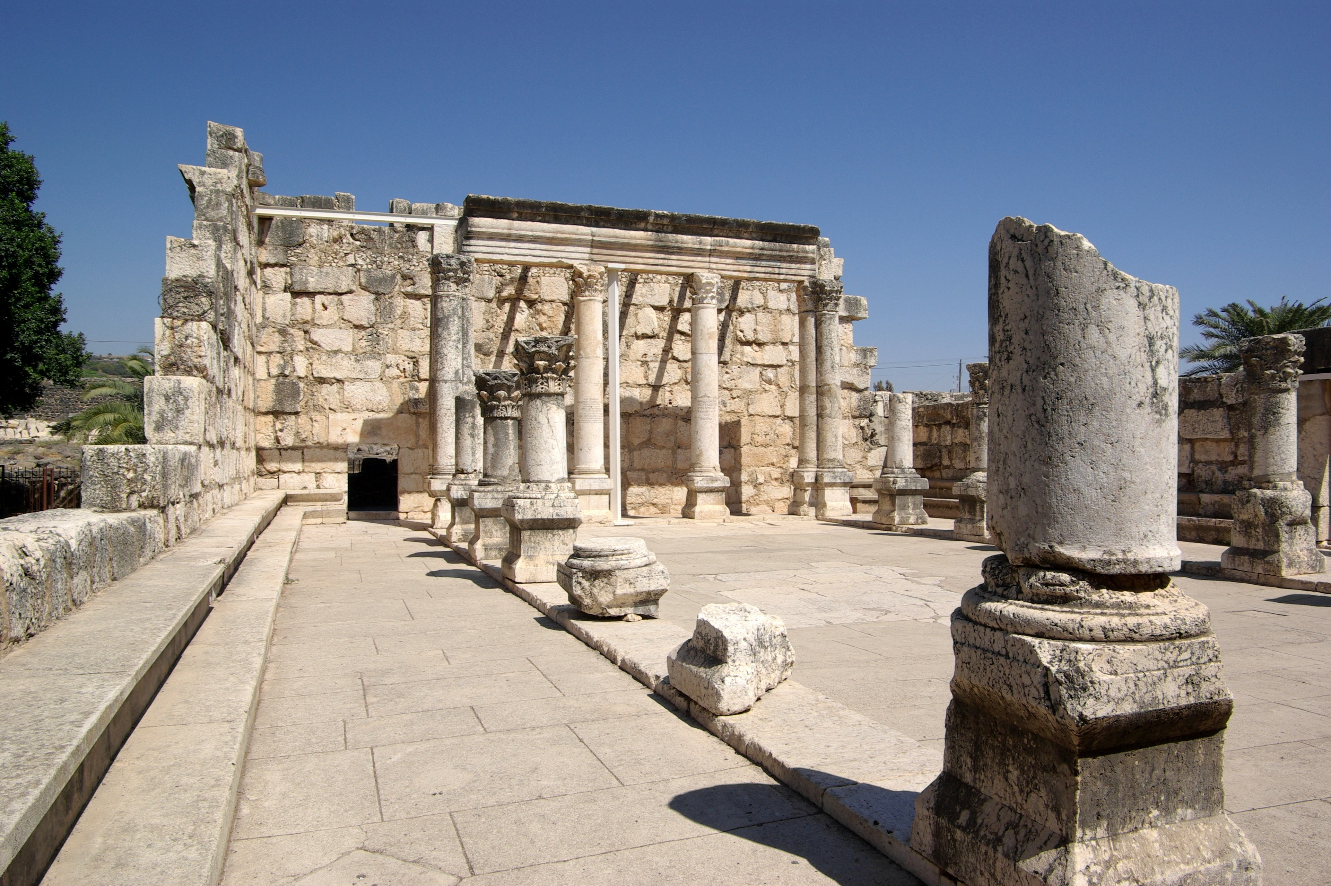

- The ancient synagogue at Capernaum [[3](https://commons.wikimedia.org/wiki/File:Kafarnaum_BW_20.jpg)]

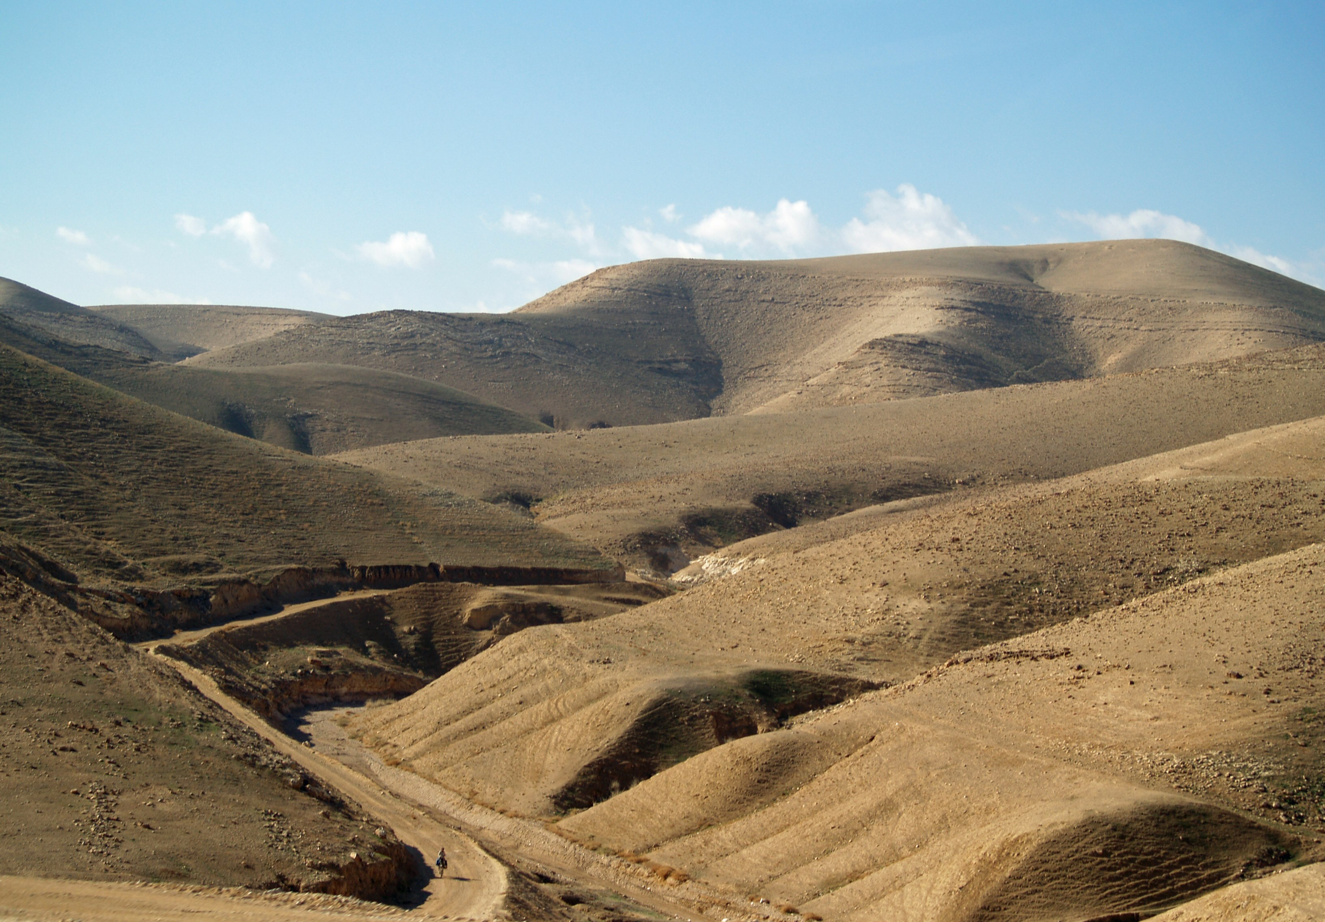

- Judean hills of Israel [[4](https://commons.wikimedia.org/wiki/File:Judea_1_by_David_Shankbone.jpg)]

You may also want to do research about: Sadducees and Pharisees in the Roman period; New prophets; Messiahs and millennial prophets; Zealots, Sicarii and bandits. [[2](https://en.wikipedia.org/wiki/Historical_background_of_the_New_Testament)]

You may also want to do research about: Jesus; Pharisees; Samaritan; Sadducees; Talmud. [[2](https://en.wikipedia.org/wiki/Historical_background_of_the_New_Testament)]

# Analysis of the gospels

You may also want to do research about: Logia; Kingdom of God; Constantine I and Christianity; crucifixion; Q source. [[2](https://en.wikipedia.org/wiki/Historical_background_of_the_New_Testament)]

# The divergence of early Christians and Rabbinic Jews

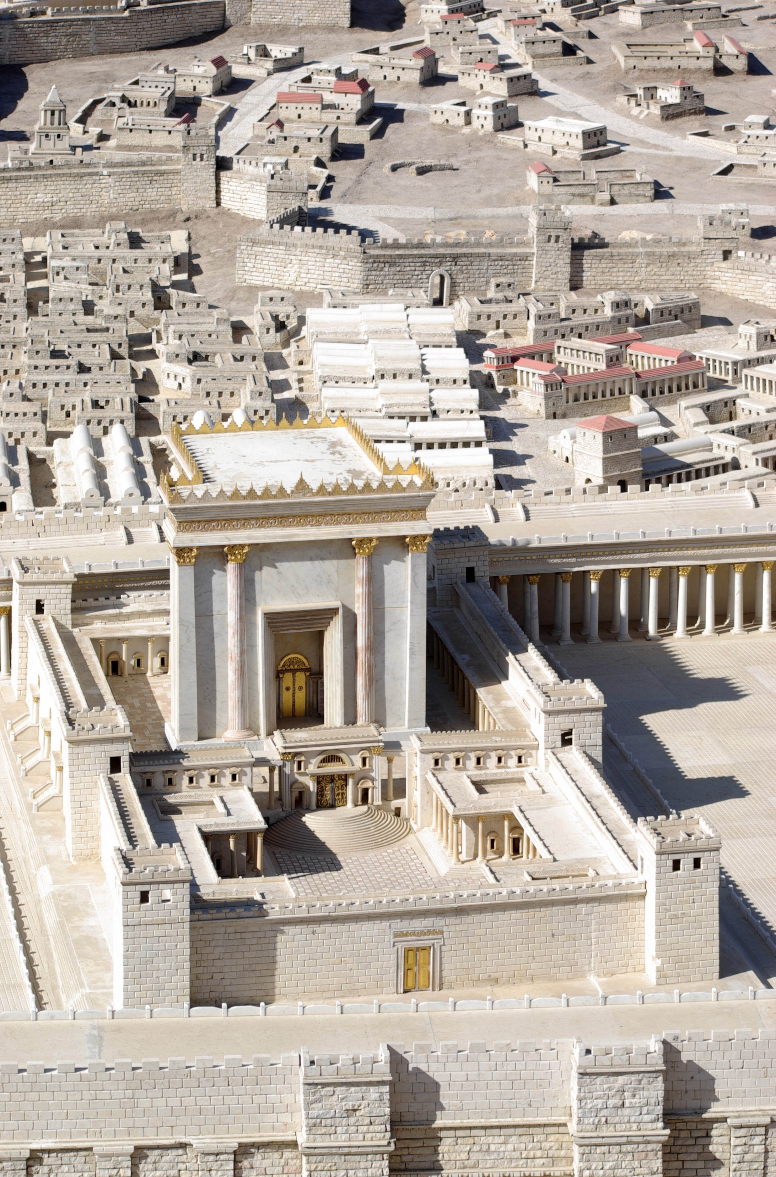

- Model of Jerusalem Temple. [[5](https://commons.wikimedia.org/wiki/File:Jerusalem_Modell_BW_3.JPG)]

You may also want to do research about: The First Jewish–Roman War and the destruction of the Temple; Loss of records; The Emergence of Rabbinic Judaism; The Emergence of Christianity. [[2](https://en.wikipedia.org/wiki/Historical_background_of_the_New_Testament)]

You may also want to do research about: messiah; Second Temple Judaism; Siege of Jerusalem (70 CE); Pella, Jordan; Circumcision in the Bible. [[2](https://en.wikipedia.org/wiki/Historical_background_of_the_New_Testament)]

# References

1. <https://commons.wikimedia.org/wiki/File:ChristPeterPaul.jpg>
2. <https://en.wikipedia.org/wiki/Historical_background_of_the_New_Testament>
3. <https://commons.wikimedia.org/wiki/File:Kafarnaum_BW_20.jpg>
4. <https://commons.wikimedia.org/wiki/File:Judea_1_by_David_Shankbone.jpg>
5. <https://commons.wikimedia.org/wiki/File:Jerusalem_Modell_BW_3.JPG>

**This Sway was started using auto-generated content that the author searched for.**